Questions and Exercises to work out and turn in:

Grading Guidelines (See Appendix):

In general, a right answer will get full credit when:

1. It is right (worth 25%)
2. It is right **AND** neatly presented making it easy and pleasant to read. (worth an **extra** 15%)
3. There is an **obvious and clear link[1]** between 1) the information provided in the exercise and in class and 2) the final answer. A clear link is built by properly writing, justifying, and documenting an answer (worth an **extra** 60%).
4. Calculation mistakes will be minimally penalized (2 to 5% of full credit) while errors on units will be more heavily penalized.

**Late Submission** : as specified in the syllabus. Day counting starts one minute after the deadline.

**Check Your Submission:**  after submitting, download your submission to check whether it is the right version and it is complete.

You are welcome/encouraged to discuss exercises with other groups or the instructor. But, ultimately, **personal** writing is expected.

* USE THIS FILE AS THE STARTING DOCUMENT YOU WILL TURN IN. **KEEP IN THE QUESTIONS** AND INSERT YOUR ANSWERS.
* IF USING HAND WRITING (STRONGLY DISCOURAGED), REWRITE THE QUESTIONS.
* FAILING TO FOLLOW TURN IN DIRECTIONS /GUIDELINES WILL COST A 30% PENALTY.

Objectives of this assignment:

* Initiate you to work on a Unix like system
* Introduction to basic Unix commands.

What you need to do: (Start early: many problems could arise.)

* Execute basic Unix commands on Engineering Tux machines.
* Always document your work by taking/inserting screenshots. To save space, clip out the screenshots to contain only relevant information.
* Insert answers as indicated (right after the question/directions)

Exercise 1 (100 points) (Well written short answers are acceptable for this assignment)

The objective of this exercise is to get familiar with basic commands to create a few directories for this course on the H (Home drive) using a Tux machine.

**Task 1**: (10 points)

Log in remotely on the Engineering Tux machines

**Help to log on**: (See attached **Video**))

**Method 1**: To log in remotely, you must use an **ssh** client such as *SecureCRT* (Windows). The software *SecureCRT* is available on AU Install. It runs only on Windows.

**Method 2**: On Windows 10, you may use from the command prompt the following command (if ssh is available): ssh username@gate.eng.auburn.edu

where username is your Auburn University username.

**Method 3**: On Mac or any Unix machine (Ubuntu...), use the same command

ssh username@gate.eng.auburn.edu on a terminal.

After you successfully succeed to log onto a Tux machine, take and insert a screenshot of the window of SecureCRT or your terminal (on Mac, Windows or any other command terminal).

**Proof/Answer**

Below is a screenshot of me successfully logging into a TUX machine using the command prompt on my Windows 11 operating system. The TUX machine the system assigned to me once pressing enter when prompted was tux239. I also captured the window to show the date and time.

**Task 2**: (Pay attention to the questions in blue. Answer those questions)

**In order to save space, for this assignment and *FUTURE* ones, clip out the screenshots to contain only the relevant information. *When applicable, ALL screenshots must show the date, the Tux machine you are using for the exercise and the Auburn username*. Make sure that the screenshots are easily readable. Below is template screenshot:**

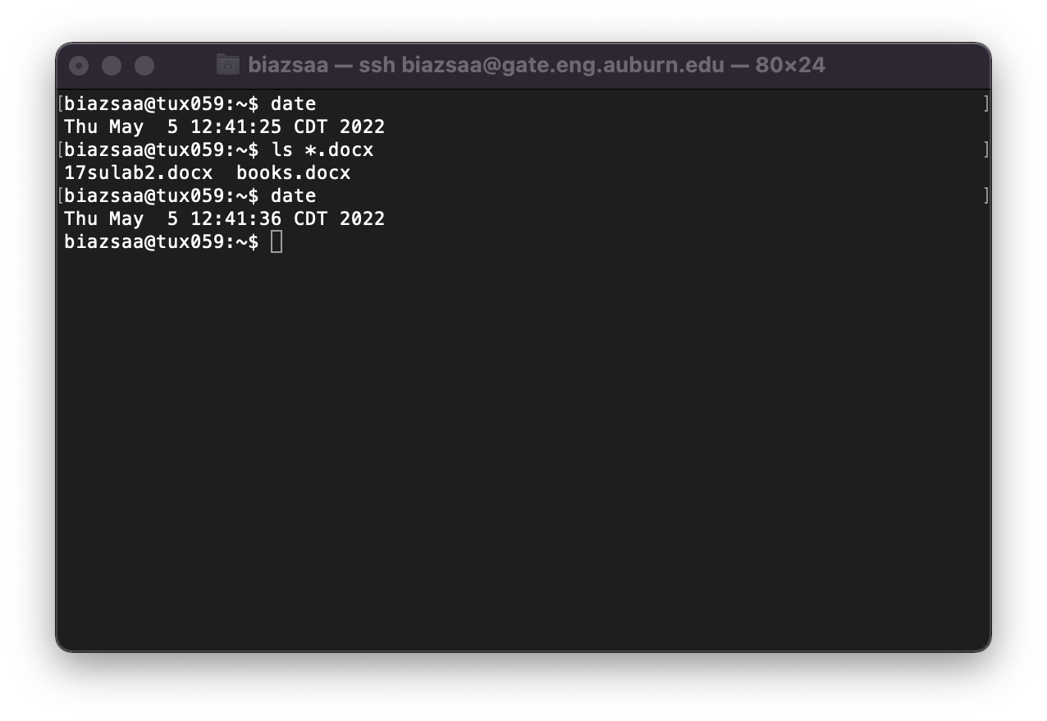

After you log onto a Tux machine, you must create a parent directory named nnnn where nnnn is this course's number. If this course's number is 3270, then you must name the parent directory 3270. You can think of "directory" as a folder (for Windows or Mac OS terminologies). We call the Directory nnnn a *parent* *directory* because this directory will contain all directories and files that you will create for this course. You must create inside the parent directory nnnn seven directories called lab1, lab2, lab3, ....., lab6, and lab7. To help you complete this task, we will guide you through the first steps:

1) As soon as you log in, type on the command line: ls

(5 points) what does the command ls do? You could use the command man ls

Answer here ......

The “ls” command will list the names of files in a particular Unix directory. If the “ls” command is typed and entered with no parameters, the command displays the files listed in the current working directory.

(4 points) what does the command man do? You could use the command man man

Answer here ......

The “man” command allows users to view the reference manuals of a command or utility run in the terminal. “man” is short for manual, and it will include a command description, applicable options, flags, examples, and other informative sections based on its contents.

2) (9 points) type the command ls -al

What is the difference between ls and ls -al?

Answer here ......

The command “ls” is meant to show a simple list of all files and directories in a more basic format. When the “ls -al” command is used it will show the same list of files and directories but in a more detailed format that includes also hidden files and directories. The difference between the two formats is as follows when pertaining to the more detailed “ls -al” command:

1. A column will represent the files permissions of each files and directory which indicates who can read, write or execute the file.
2. A column will represent the owner of the file with the username or UserID.
3. A column that will represent the file’s size.
4. A column that will represent the last modified date and time.
5. A column that represents the number of times a file is referenced throughout all other files and/or directories.

3) (9 points) type the command mkdir nnnn (where nnnn is this course's number)

The above command mkdir nnnn will create a directory named nnnn. Type the command ls -al to check that this directory named nnnn was created inside the home directory: the home directory is the default directory you are in when you log on a Tux machine.

Take a screenshot showing the list of files or directories inside the current directory (home).

Insert the screenshot here...... (clip out the screenshot to show only the relevant information)

**Proof/Answer**

This shows using the “ls -al” command the details of “3330” being created. I also show this using just the “ls” command to show the directory “3330”. The date and time are viewable at the bottom right.

4) (9 points) type the command cd nnnn (where nnnn is this course's number) (this command will "*move*" you into the directory nnnn

Take a screenshot showing the prompt.

Insert the screenshot here...... (clip out the screenshot to show only the relevant information)

**Proof/Answer**

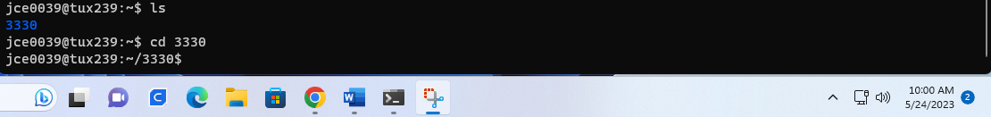

As seen in the screenshot above, I was able to “move” into the directory named “3330” on the tux239 machine within my “jce0039” username.

5) (9 points) type the command ls -al

Take a screenshot showing the list of files or directories inside nnnn.

Insert here screenshot here ...... (clip out the screenshot to show only the relevant information)

**Proof/Answer**

As seen in the screenshot above, I was able to show the details using the “ls -al” command within the “3330” file directory I was just able to create.

You should see two files (or directories?) named '**.**' and '**..**'

Search on Google what '**.**' and '**..**' are.

What are those "files" (or directories?) '**.**' and '**..**'?

Answer here....

'.' (dot): The single dot refers to the current directory. When you are inside a directory, '.' represents that directory itself. So if I was to create a file within 3330 named lab1 and “moved” into that file the ‘.’ Would be represented as “lab1”. The ‘..’ would be considered the parent directory and be the directory “3330”.

'..' (dot dot): The double dot refers to the parent directory. It represents the directory one level above the current directory. Again “3330” would be the parent directory of the file lab1 that I will create below.

The '.' and '..' directories are present in every directory within a file system. They are used to navigate and reference directories relative to the current location. This gives more control to the user to navigate around a directory without having to use other/extra commands to complete task that will be needed overtly.

6) (9 points) Create 7 directories named lab1, lab2, lab3, ....., lab6, and lab7 inside the directory nnnn. List below the commands you must type to create 7 directories named lab1, lab2, lab3, ....., lab6, and lab7.

Answer here (list here the commands) .... (clip out the screenshot to show ........relevant ...)

**Proof/Answer**

As seen in the screenshot above, I was able to use the “mkdir” command while located inside the “3330” directory to make the 7 different other folders needed for each module.

7) (9 points) type the command ls -al

Take a screenshot showing the list of files or directories inside Directory nnnn.

Insert here screenshot...... (clip out the screenshot ...... ........... ...)

**Proof/Answer**

As seen in the screenshot above, I was able to use the command “ls -al” to show a detailed view of the files/folders within the directory “3330”. Also, you can see the time and date. Also, viewable here is the TUX machine “tux239” that I am using for this, while also being located in the directory “3330” of the username “jce0039”.

8) (9 points) What command should you type to "*move*" inside the directory lab3

Provide here the command needed to "*move*" inside the directory lab3

Answer here....

The command needed to “move” inside the directory lab3 is “cd lab3”. Since I am already located within the directory “3330”, I do not have to add a file path that includes that. If I was not already located within that parent directory, then I would have to include that within the path. As in “cd 3330/lab3”, but again this was not required since I am already located in that directory.

9) (9 points) type the command ls -al (while inside the directory lab3)

Take a screenshot showing the command line "ls -al" and the content of the directory lab3.

Insert here screenshot...... (clip ......)

**Proof/Answer**

**Proof/Answer Shown above is a screenshot showing me using the “cd” command to “move” into the folder named “lab3”. After which I then used the command “ls -al” to show a detailed view of this folder. The ‘.’ And ‘..’ are automatically present within the folder to help navigate the directory.**

10) (9 points) which command should you type to "move up" to the parent directory of lab3?

Answer here. Tell us how you found the command.

**Proof/Answer**

I was able to simply recall previously within the lab what the use of ‘..’ is in reference to. That with the command we have used to “move” into other directories or subdirectories. So the “cd” command used with ‘..’ will move me into the parent directory. This will in turn “move up” to the parent directory of lab3. The whole command used while within the lab3 folder is “cd ..”. I have also captured a screenshot of moving up to the parent directory of “lab3”. This also shows the date and time on the system.

**Proof/Answer**



**Start early**: many problems could arise.

**If you have problems to log in remotely to Tux machines, ask on Piazza for help.**

What you need to turn in:

* Electronic copy of this file (including your answers) (standalone). Submit the file as a Microsoft Word or PDF file.
* Recall that answers must be well written, documented, justified, and presented to get full credit.
* How this assignment will be graded:
* A right answer will get full credit when:
* It is right (worth 25%)
* It is right AND neatly presented making it easy and pleasant to read. (worth 15%)
* There is an obvious and clear link between 1) the information provided in the exercise and in class and 2) the final answer. A clear link is built by properly writing, justifying, and documenting an answer (worth 60%).
* Calculation mistakes will be minimally penalized (2 to 5% of full credit) while errors on units will be more heavily penalized.
* You are welcome/encouraged to discuss exercises with other students or the instructor. But, ultimately, personal writing is expected.

**Appendix**: Grading: What is an OBVIOUS and CLEAR LINK?

Here is an example to explain what an **obvious and clear link** is and how we grade your work.

Consider the following problem:

"(100 points) John travels from Auburn to Atlanta in his car at a speed of 50 mph. Leaving at 8am, at what time will John reach Atlanta".

Here are the answers of three students and their scores:

**Student 1** answers: "10am". Student 1 will get 25 points.

**Student 2**answers : "John will reach Atlanta at 10am". Student 2 will get 25+15 = 40 points

**Student 3** answers: "The time t to travel a distance d at speed v is equal to d/v = d/50mph. The problem does not provide the distance d from Auburn to Atlanta. Based on Google, the distance from Auburn to Atlanta is approximately 100 miles (**document is here**). Therefore, the time t = 100 miles/50mph = 2 hours. Since John left at 8am, he will then reach Atlanta at 8am + 2 hours = 10 am".

**Student 3** will get 25 + 15 + 60 = 100 points

Do you see the **direct** **link** going from the data provided in the question to the final answer, using general knowledge/formula and documents?.... Can you now solve the following problem and get 100 points?

"(100 points) Alice travels from Auburn to Atlanta in her car at a speed of 50 mph. Leaving at 8am, at what time will Alice reach Atlanta assuming that she had a flat tire that delayed her 30 minutes".

**Screenshot: Required Information**

**In order to save space, for this assignment and all *FUTURE* ones, clip out the screenshots to contain only the relevant information. *When applicable, ALL screenshots must show the date, the machine you are using for the exercise and the username of one of the team mates*. Make sure that the screenshots are easily readable. Below is template screenshot:**



1. See on the appendix what an obvious and clear link is.